**Database Design Coursework Template**

Student Name: Silmoon Hossain

Student ID: 240010885

Student Number: 240010885

**Scenario Topic Name** : Advanced Health and Fitness Monitoring System

**Scenario** (100 words maximum)

The Advanced Health and Fitness Monitoring System allows users to track their daily wellbeing and activities through smart devices like fitness bands or smartwatches to improve energy levels and optimise their fitness to feel and perform the best. The system records data, such as recovery scores, energy burned and other metrics. Managers or coaches can oversee users' progress to help them better. The system allows user to track activities like workouts or sleep to visualise useful trends. Users can also log habits in a daily journal to see how these affects other aspects of their life.

**Example queries** (Minimum 5 – list, who, which, how many, most, fewest etc. - check that your models have the attributes needed to answer the queries)

For the Manager:

* List all users and their corresponding devices.
* Which users have logged less than 2 workouts in the last week?
* List the users with a recovery score less than 60%, their total sleep time, and when they went to sleep.
* List the top 5 users with the highest energy burned in the past month.

For the User:

* List my recovery score in the past week?
* How has my average sleep duration by stage (light, deep, REM, awake) changed over the past three months?
* What is the total energy I burned each day over the past three months?
* How often did I spend more than 30 minutes in a high heart rate zone during my workouts this month?
* How has my average workout duration changed each month over the past year?

**Entity Relationship Model** (insert a jpg image of your model exported from Visual Paradigm in the space below).

Insert your jpg image here

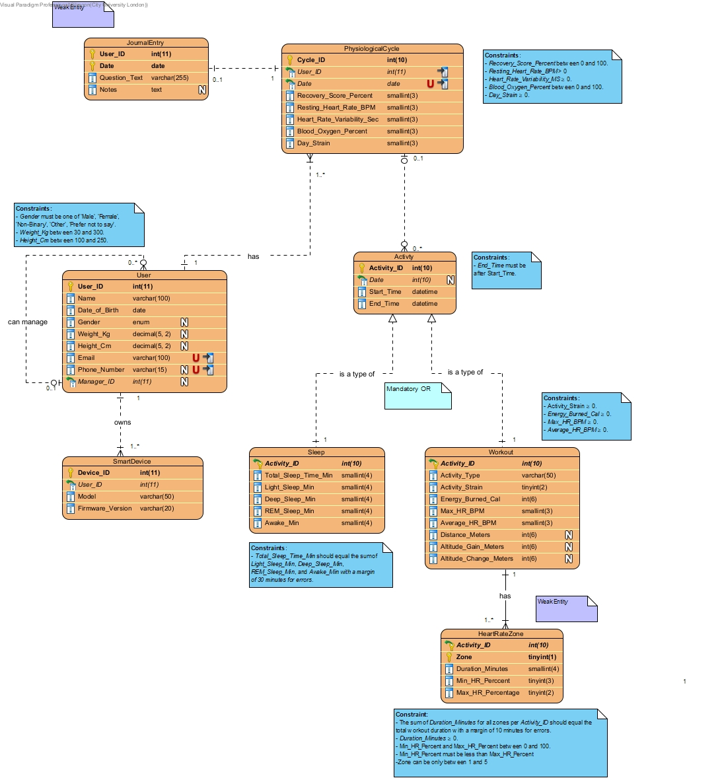

**Relational Model Tables**

* Copy and paste the table below for as many relational tables as you need
* Replace the placeholder names (table-name1, attribute-name5 etc) with the table and attribute names you derived from your ER model
* List primary key attributes first
* Add new rows to the tables (in the correct place) as needed
* Delete any unnecessary rows (attribute rows and foreign key rows if not used)
* Primary keys are to be specified in the format PRIMARY KEY (attribute-name1, attribute-name2, etc)
* Foreign keys are to be specified in the format ‘FOREIGN KEY (attribute-name) REFERENCES table-name (attribute-name)

Insert additional tables here……..

|  |  |
| --- | --- |
| **Relational table specification** | **Marker’s corrections (Do not write in this column)** |
| **Table name:** User |  |
| **Attributes** |  |
| User_ID (int) |  |
| Name (varchar(100)) |  |
| Date_of_Birth (date) |  |
| Gender (enum) |  |
| Weight_Kg (decimal(5, 2)) |  |
| Height_Cm (decimal(5, 2)) |  |
| Phone_Number (varchar(15)) |  |
| Manager_ID (int) |  |
| **PRIMARY KEY** (User_ID) |  |
| **FOREIGN KEY** (Manager_ID) **REFERENCES User(User_ID)** |  |

|  |  |
| --- | --- |
| **Relational table specification** | **Marker’s corrections (Do not write in this column)** |
| **Table name:** SmartDevice |  |
| **Attributes** |  |
| Device_ID (int) |  |
| User_ID (int) |  |
| Model (varchar(50)) |  |
| Firmware_Version (varchar(20)) |  |
| **PRIMARY KEY** (Device_ID) |  |
| **FOREIGN KEY** (User_ID) **REFERENCES** **User**(User_ID) |  |

|  |  |
| --- | --- |
| **Relational table specification** | **Marker’s corrections (Do not write in this column)** |
| **Table name:** JournalEntry |  |
| **Attributes** |  |
| User_ID (int) |  |
| Date (date) |  |
| Question_Text (varchar(255)) |  |
| Notes (text) |  |
| **PRIMARY KEY** (User_ID, Date) |  |
| **FOREIGN KEY** (User_ID) **REFERENCES** **User**(User_ID) |  |

|  |  |
| --- | --- |
| **Relational table specification** | **Marker’s corrections (Do not write in this column)** |
| **Table name**: PhysiologicalCycle |  |
| **Attributes** |  |
| Cycle_ID (int) |  |
| User_ID (int) |  |
| Recovery_Score_Percent (smallint) |  |
| Resting_Heart_Rate_BPM (smallint) |  |
| Heart_Rate_Variability_Sec (smallint) |  |
| Blood_Oxygen_Percent (smallint) |  |
| Day_Strain (smallint) |  |
| **PRIMARY KEY** (Cycle_ID) |  |
| **FOREIGN KEY** (User_ID) **REFERENCES** **User**(User_ID) |  |

|  |  |
| --- | --- |
| **Relational table specification** | **Marker’s corrections (Do not write in this column)** |
| **Table name:** Activity |  |
| **Attributes** |  |
| Activity_ID (int) |  |
| User_ID (int) |  |
| Date (int) |  |
| Start_Time (datetime) |  |
| End_Time (datetime) |  |
| **PRIMARY KEY** (Activity_ID) |  |
| **FOREIGN KEY** (User_ID) **REFERENCES** **User**(User_ID) |  |

|  |  |
| --- | --- |
| **Relational table specification** | **Marker’s corrections (Do not write in this column)** |
| **Table name:** Sleep |  |
| **Attributes** |  |
| Activity_ID (int) |  |
| Total_Sleep_Time_Min (smallint) |  |
| Light_Sleep_Min (smallint) |  |
| Deep_Sleep_Min (smallint) |  |
| REM_Sleep_Min (smallint) |  |
| Awake_Min (smallint) |  |
| **PRIMARY KEY** (Activity_ID) |  |
| **FOREIGN KEY** (Activity_ID) **REFERENCES Activity**(Activity_ID) |  |

|  |  |
| --- | --- |
| **Relational table specification** | **Marker’s corrections (Do not write in this column)** |
| **Table name:** Workout |  |
| Attributes |  |
| Activity_ID (int) |  |
| Activity_Type (varchar(50)) |  |
| Activity_Strain (tinyint) |  |
| Energy_Burned_Cal (smallint) |  |
| Max_HR_BPM (smallint) |  |
| Average_HR_BPM (smallint) |  |
| Altitude_Gain_Meters (smallint) |  |
| Altitude_Change_Meters (smallint) |  |
| **PRIMARY KEY** (Activity_ID) |  |
| **FOREIGN KEY** (Activity_ID) **REFERENCES** **Activity**(Activity_ID) |  |

|  |  |
| --- | --- |
| **Relational table specification** | **Marker’s corrections (Do not write in this column)** |
| **Table name:** HeartRateZone |  |
| **Attributes** |  |
| Activity_ID (int) |  |
| Zone (tinyint) |  |
| Duration_Minutes (smallint) |  |
| Min_HR_Percent (smallint) |  |
| Max_HR_Percent (smallint) |  |
| **PRIMARY KEY** (Activity_ID, Zone) |  |
| **FOREIGN KEY** (Activity_ID) **REFERENCES** **Activity**(Activity_ID) |  |

**Marker’s Comments** (Do not write in this section)

**Important:** Please note that marker’s corrections to your relational tables are there to help you construct a working database for the second coursework. They are not the determinant of your mark. For more information on how your work is assessed see the coursework specification and grade related criteria.

**Coursework Mark** (100 marks available):